2025
9زارة الإلستثماب 1
Ministry of Investment

Investor Guide
12th Edition 04– 2025



Contents

- Objective of the Guide
- Introduction
- Ministry of Investment Services
  - Investment Registration
    - Registration
  - Post-Registration Services.
    - Annual Renewal
    - Merge Investment Registers
    - Amendment of ownership in registration
    - Amendment on Economic Activities
    - Approval to own and sell the property
      - Approvals to own/sell real estate to engage in investment activity
      - Approvals for ownership/sale of real estate activities
    - Updating facility information and data
    - Cancel registration
      - Informing for the purpose of voluntary cancellation of registration
      - Issuing a decision to voluntarily cancel registration
  - Value-Added Services
    - Strategic Investor Program
    - MISA Program
    - 4.Government Services at the One-Stop- Shop Centers
  - Ministry of Justice
  - Ministry of Human Resources and Social Development
  - Ministry of Interior
    - General Directorate of Passports
    - Recruitment Affairs Directorate
  - General Organization for Social Insurance
  - Ministry of Foreign Affairs
- . Requirements and Obligations
  - Requirements for registration of special categories
  - Specific requirements, conditions, and obligations
    - Types of activities, their requirements, minimum capital requirements, and national participation percentage
    - Requirements for registering special categories
    - Additional obligations based on the type of registered activity
- .Contact the Ministry of Investment
  - Communication Channels
  - Contact Information
- .Attachments
  - List of Violations
    - List of serious violations:
    - List of non-serious violations:

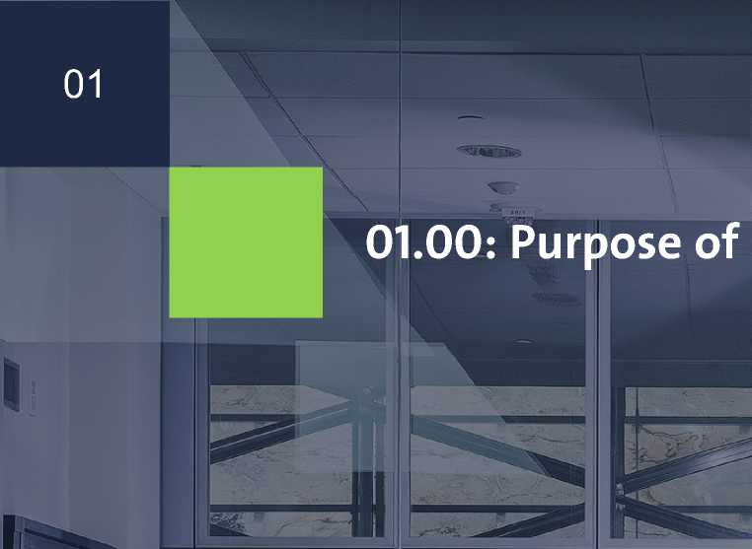


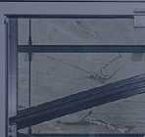

This guide aims to clarify the requirements and procedures of the services provided by the Ministry of Investment to enhance efficiency and ensure high-quality service execution for clients. It also serves as a reference for all Ministry employees, clients, and relevant entities, promoting transparency, clarity, and standardization of service procedures.




02


02.00: Introduction to Investment Registration in the Kingdom
The procedures for registering new investments in the Kingdom and making amendments are based on solid foundations and objective criteria. These procedures aim to attract and empower serious investments that positively contribute to national economic growth and sustainable development, including:
Development of Saudi human resources

Technology transfer and localization

Enhancing economic competitiveness in local and global markets
Diversification of income sources

Balanced regional development.

Export growth

The Ministry of Investment welcomes investors who possess distinguished local or international expertise, financial capability, and organizational structure to activate their investments in the Kingdom.
The Ministry also works on improving the investment environment by offering various opportunities, attracting high-value investments, and providing advanced e-services that ensure speed and flexibility in transactions between investors and the Ministry. Additionally, it coordinates with relevant government agencies and offers post-registration services through Investor Relations Centers.
Furthermore, the Ministry seeks to facilitate the entry of entities with added value, as well as holders of special residency permits, to explore the Saudi market and establish companies under the corporate laws.

03






ح
بلم


03.00: The Ministry of Investment

Services
03.01.01: Registering for investment


04

    - Registering for investment

Service Description
This service enables establishments to register for investment in the Kingdom in accordance with the Investment Law and its Executive Regulations. Registration is available for approved economic activities in Saudi Arabia open to investment (ISIC4) According to the requirements of the activity category (available or restricted).
Service Fees
The applicant commits to paying the registration fee later, as determined by the ministry upon approval of the application. Payment must be made within a period not exceeding fifteen (15) business days from the date of notification of the due amount for the service; otherwise, the registration will be considered void.
Service Application Portal
Service Application Portal
Estimated Processing Time
10 Working Day

Service Requirements
- A copy of the commercial register of the participating foreign establishment, certified by the Saudi Embassy.
- A copy of the identity document if one of the partners is a natural person (individual) holding the nationality of a GCC country (if their information is not registered in the Absher system).
- Financial statements for the last fiscal year of the foreign company applying for registration, authenticated by the Saudi embassy.
- Providing the requirements related to the type of activity to be registered in accordance with Section (05.00) of this guide.
- Holders of the Special Residency Permit are exempted from submitting requirements (1-3) above.

Service Conditions & Restrictions
- Total percentage of Saudi partner(s) and the capital according to the minimum limits specified for the type of activity type in Section (05.00) of this guide.
- Compliance with the specific conditions outlined for the activity to be registered, as per Section (05.00) of this guide.

05








03.02: Post-Registration
Services






06

    - Annual Registration

Update

Service Description
This service allows for the annual update of data or information of the facility registered in the Ministry of Investment’s systems in accordance with what is stipulated in the executive regulations of the investment system..

Required Documents
None

Service Conditions &

Restrictions
None

Service Fees
The applicant commits to paying the annual update fee later, as determined by the ministry upon approval of the application. Payment must be made within a period not exceeding fifteen (15) business days from the date of notification of the due amount for the service; otherwise, the registration will be considered void..
Service Application Portal Electronic Services Portal - Investment Registration

Estimated Processing Time
5 working days



Service Conditions & Restrictions
- Fulfilling the conditions and requirements for each service associated with the procedure to be implemented
- The integration of investment registers and the transfer of economic activities are in accordance with the regulations and categories of investment registers (the following categories of investment records are not integrated: Regional Headquarters(RHQ)/Scientific offices/Economic offices/Professional companies)
- The establishment must comply with the procedures for amending the partners’ decision and registering the commercial register within 30 days from the date of amending the investment registration. If this is not done, the Ministry of Investment has the right to restore the investment register data to its previous status.
- The total percentage of Saudi (partner(s) and capital shall be consistent with the minimum limits specified for the type of activity in Section Five of this guide.
- Fulfilling the special requirements contained in Section Five of this Guide.
Service Fees
No fees apply
Service Application Portal
Electronic Services Portal - Ministry Services
    - Merge Investment Registers

Service Description
This service is provided to establishments
that have more than one investment registration and wish to merge these registrations into a single registration, or to establishments that wish to acquire a different establishment.
Merging cases:
If the request is to acquire an independent legal entity with different partner(s):
- In the case of a change in partners, a change in shares between partners, or a change in capital, Must be applied for service number 3.2.3.
- If you wish to add economic activities, apply for the activity modification number service 3.2.4.
- A request is submitted to cancel one of the establishments/establishments Cancellation service number 3.2.7
If the application is to merge investment records owned by one legal entity and the same partner(s):
- In the case of a change in shares between partners, or a change in capital, Must be applied for service number 3.2.3.
- If you wish to add economic activities, apply for the activity modification number service 3.2.4
- A request is submitted to cancel one of the establishments/establishments Cancellation service number 3.2.7

Required Documents
- Depending on the type of modification required
- Partner's decision of merge
Estimated Processing Time
5 working days

08
- 2.3 Amendment of ownership in registration

Service Description
This service is available for companies that wish to modify ownership, for example, by redistributing shares among partners, entering or exiting partners, replacing heirs, or converting the establishment to another 100% national company according to a notarized decision of the partners, or establishments registered with the Ministry of Investment that wish to merge into another existing company of its kind or of another type, or by merging two or more companies to establish a new company according to a decision of the partners approved by the official authorities And what may accompany these changes of amendments to the investment register.
Service Fees
No fees apply.
Service Application Portal
- Electronic Services Portal
- Investment Registration Estimated Processing Time
5 working days
Required Documents
- Partners resolution approving the requested modification, authenticated by the Chamber of Commerce or the Saudi embassy for partners outside the Kingdom.
- For new partners: Required documents as per the registration conditions outlined in Section (03.00) of this guide.
- In cases of succession by heirs: A letter issued by the court or an accredited law firm specifying the legal distribution of shares among the heirs and the exact ownership percentages in the facility.
Service Conditions & Restrictions
- The establishment must complete the amendment of the partner resolution and update the commercial registration within 30 days from the date of investment register modification. Failure to do so allows the Ministry of Investment to revert the register data to its previous status.
- Total percentage of Saudi partner(s) and the capital according to the minimum limits specified for the type of activity type in Section (05.00) of this guide.
- Compliance with the specific requirements outlined for the registered activity, as per Section (05.00) of this guide.

09
    - Amendment on Economic Activities
Service Description
This service enables the establishment to
modify, add or delete activities in its investment register in accordance with the procedures regulating the type of activity (available-restricted).
Required Documents
Fulfilling the special requirements contained in Section Five of this Guide.
Service Conditions & Restrictions Fulfilling the special requirements contained in Section Five of this Guide.
Service Fees
No fees apply
Service Application Portal
Electronic Services Portal - Ministry Services
Estimated Processing Time
5 working days

10
    - Approval to own and sell the property
      - Approvals to own/sell real estate to engage in investment activity

Service Conditions & Restrictions
- The purpose of the sale must not be for commercial trading.
- The property must be located outside the boundaries of Makkah and Madinah.

Service Description
This service is available for establishments registered with the Ministry of Investment that wish to obtain an approval decision to own or sell the property necessary for them to practice their registered economic activities. It includes the following purposes:
- Own a property as Personal housing.
- Own a property as Industrial facility headquarters.
- Own a property as the company's administrative headquarters.
- Own a property for workers housing.
- Own a property as Warehouses.
Service Fees
No fees apply.
Service Application Portal
Electronic Services Portal - Ministry Services
Estimated Processing Time

Required Documents
- copy of the municipal building permit, an approval letter from the municipality, or an official document specifying the land use from a relevant authority.
- copy of the title deed for the property to be purchased must be attached.
5 working days.


- 2.6 Updating facility information an data

Service Description
This service aims to provide the Ministry of Investment with an update on the establishment’s data, for example (legal entity – name of the establishment – nationality of the partner – location – contact officer) and with the information of the general manager and representatives of the establishment, and to designate a delegate with the ministry to receive notices, notifications, decisions, and the like. As well as submitting requests for the facility to the Ministry.

Required Documents
- Depending on the type of update requested

Service Conditions &

Restrictions
None

Service Fees
No fees apply.

Service Application Portal
Electronic Services Portal - Investment Registration

Estimated Processing Time
- Working days
- .2.5.2 Approvals for ownership/sale of real estate activities

Service Description
This service is available for establishments registered with the Ministry of Investment that practice specialized activities in real estate development to implement or sell a real estate project.

Required Documents
- A report from an engineering office accredited by the Saudi Council of Engineers, specifying the total project cost in case of a purchase request.
- A copy of the title deed for the property to be purchased or sold must be attached.

Service Conditions &

Restrictions
- The total project cost (land and construction) must not be less than 30 million SAR.
- The property must be located outside the boundaries of Makkah and Madinah.
- The establishment must utilize the acquired land for the specified purpose within five years.

Service Fees
No fees apply.

Service Application Portal
Electronic Services Portal - Ministry Services

Estimated Processing Time
5 working days.

12

3.2.7.2 Issuing a decision to voluntarily cancel registration Service Description
This service is available for all establishments
that wish to issue a decision for voluntary registration cancellation after completing the termination and cancellation of all records, licenses, and certificates associated with their registration with the Ministry of Investment.
Required Documents
- A certificate of commercial registration cancellation or a statement of non-issuance of a commercial registration issued by the Ministry of Commerce.
- Proof of the cessation of the unique number with the Zakat, Tax, and Customs Authority.
Service Conditions & Restrictions
Before applying for the service, the establishment must ensure the following:
- Workers have been cleared.
- The establishment's location is closed, and the activity has ceased.
- The establishment must not be operating or practicing any activity, either directly or indirectly.
- The commercial registration must be canceled with the Ministry of Commerce.
- Terminate all obligations to external parties, including the Ministry of Investment.
Service Fees
- No fees apply.
Service Application Portal
Electronic Services Portal - Investment
Registration

3.2.7 Registration Cancellation
      - Confirmation for Voluntary Cancellation

Service Description
This service is available for all establishments that wish to voluntarily cancel their registration and require endorsement letters from relevant government entities to facilitate the completion of their procedures and the liquidation of the establishment.

Required Documents
- None

Service Conditions &

Restrictions
- None

Service Fees
- No fees apply.
Service Application Portal Electronic Services Portal - Investment Registration

Estimated Processing Time
2 working days.
Estimated Processing Time
2 working days

13
3.3 Value-Added Services
3.3.1 Strategic Investor Program
Service Description & Benefits
The Strategic Investor Program offers a package of services and benefits to both national and foreign companies that meet the eligibility criteria announced on "Invest in Saudi Arabia." The program aims to enhance the investment environment, create new opportunities for investment, and strengthen confidence This leads to the diversification of economic activities and an increase in the local economy. The key benefits include:
- Support for the development of investment opportunities
- Provision of specialized economic sector data and information
- Investment reports tailored to foreign countries investing in Saudi Arabia
- Advisory support on legislation and regulations in Saudi Arabia
- Support for issuing professional and operational licenses.
- Guidance on industrial and economic zones
- Consultation on visa requirements and procedures
- Consultation on Saudization requirements and procedures
- Support and solutions to enable investors.
- Support for finding Saudi talent (Miza)
- .Development of investment opportunities in international markets
- Support for communication with foreign governments on investment matters
- Consultation on investment incentives
- Guidance on funding opportunities
- Development of commercial and investment partnerships (alignment)
- Strengthening collaboration in research and development with research centers
Key Benefits for Program Participants
- Priority access to events
- Event sponsorship and partnership opportunities
- A regular newsletter to track developments in business laws and regulations in Saudi Arabia
- Membership in other government programs for prominent investors
- Access to exclusive products from the private sector
- Dedicated relationship manager support
- Facilitation of obtaining premium residency
- Opportunities to network with decision-makers and leading investors in the Kingdom
- Exclusive channels for investor feedback and suggestions


14


Required Documents for the Service
• Attach the required documents in the
electronic application submission form.
Service Fees
The establishment must pay the service fees, if applicable, as determined by the Ministry upon approval of the classification mechanism. Payment must be made within 30 days from the notification date of the classification and the applicable fees.
Service Application Portal
Electronic Portal – Strategic Investor Program
Estimated Processing Time
5 working days
Service Conditions & Restrictions
- Registration on the Ministry of Investment website.
- Meeting the eligibility criteria based on the establishment's classification.
Eligibility Criteria
- Companies registered in prominent government programs.
- Company size and economic impact.
- Strategic companies.
For more details about the program and services offered, visit [here].
Target Groups (Eligible Entities)
- National companies
- Foreign companies registered with the Ministry of Investment
- Companies not registered in the Kingdom.

15

Service Description
Miza is a leading program under the National Investment Strategy initiatives aimed at enhancing the investor's experience through a seamless and integrated investment journey in the Kingdom of Saudi Arabia. The program offers value-added services through a regulated electronic portal that facilitates investors' access to private sector business service providers, boosting the efficiency of the investment environment and supporting a competitive and sustainable business ecosystem.

Types of Services
The Miza program provides a wide range of services across 12 service portfolios for both local and foreign investors:
- Communication and Events
- Talent Solutions
- Market Entry Support
- Legal, Tax, and Compliance Services
- Market Analysis
- Real Estate Services
- Financial and Accounting Services
- Digital and Technology Services
- Ongoing Investor Support
- Concierge and Logistics Services
- Marketing and Public Relations
- Investor Alignment
R^{e}q^{u}i^{re}d D^{ocumen}t^{s} f^{or} th^{e} Service Conditions & Restrictions Service Fees
Service
• Registration on the Ministry of • No fees
• None egs ra onon e ns ryo Investment website
Electronic Portal – Miza Program
Service Application Portal _{Estimated Processing Time}
• Electronic Portal – Miza Program • Depends on the type of service
requested.
For more details about the program and the services provided, visit [here].
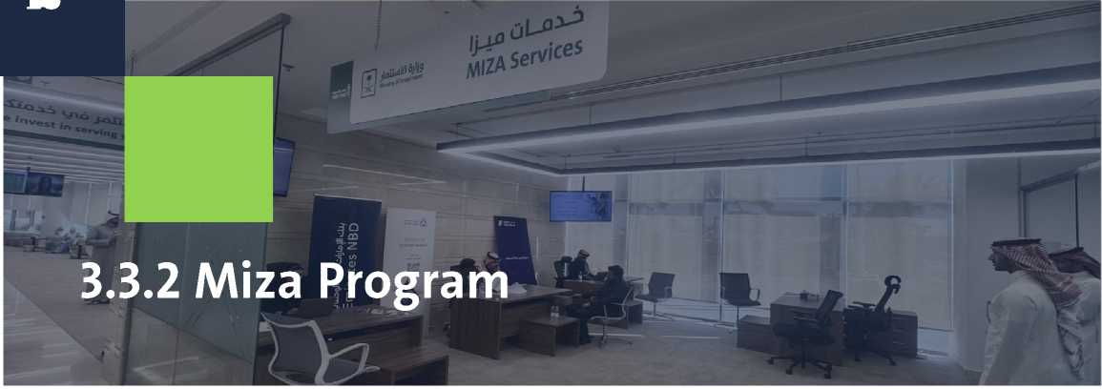

16


04.00: Government Services at
One-Stop-Shop Service Centers

17

04.01.02 Industrial Mortgage

Service Description
This service is provided to industrial companies that wish to mortgage assets to obtain specific facilities or services.

Required Documents
- Copy or number of the commercial registration.
- Articles of incorporation for companies (showing authority for the company's manager to mortgage and sign on behalf of the company), or a legal power of attorney specifying the mortgage.
- If the mortgaged asset includes property, the original deed must be attached.
- Provide a letter requesting the Ministry of Investment’s endorsement of the mortgage.
- Provide a letter from the Industrial Development Fund.
- Provide a statement of the mortgaged assets.

Service Conditions & Restrictions
- The letter of approval from the Ministry of Investment must include specific details about the mortgaged property, such as the deed number and date, and mention the requesting authority (e.g., court, etc.).

Service Fees
Payment of applicable fees for the government agency providing the service (if any).

Service Application Location
One-Stop Services centers (Jeddah, Dammam).
04.01 Ministry of
Justice
04.01.01 Issuance of Power of Attorney

Service Description
This service is provided to companies that wish to issue powers of attorney to representatives for following up on their business operations.

Required Documents
- Copy of the commercial registration.
- Proof of identity of the applicant and their position.
- Articles of Incorporation.

Service Conditions &

Restrictions
- The application number must be attached, filled electronically on the Ministry of Justice website.
- The official power of attorney form must be completed electronically.
- For those holding a visitor visa, registration in the Absher service with the border number is required.

Service Fees
Payment of the applicable fees for the government agency providing the service (if any).

Service Application Location
One-Stop Services centers.

Service Application Location
- working day.
Service Application Location
1 working day.

18

Service Conditions & Restrictions
For Heirs:
- The in-kind shares must be detailed (e.g., vehicles should specify type, model, and value; buildings and facilities should specify whether they are leased or provided by the partners).
- Update the investment registration based on the inheritance deed and legal office's letter.
- The heirs or their representative must be present.
For Minors:
The guardian or legal representative must either be present with a power of attorney or guardianship.
For Judicial Rulings:
A letter from the family court authorizing the requested amendment, whether it is for sale, transfer, etc., is required.

Service Fees
Payment of applicable fees for the government agency providing the service (if any).

Service Application Location
- One-Stop Services centers (Jeddah) for requests concerning heirs or minors.
- One-Stop Services centers (Dammam) for requests concerning heirs, minors, or judicial rulings.

04.01.03 Documenting of Company

Establishment Contracts

Service Description
This service is provided to companies wishing to document a new or amended founding contract (for heirs, minors, or judicial rulings).

Required Documents
- Proof of identity for the partners and the company's establishment contract, along with any amendments (if applicable). Alternatively, provide the original notarized and stamped power of attorney, with translations, from all company partners or the manager authorized to sign the establishment contracts.
- A notarized authorization for the applicant, with proof of the identity of the authorized person, or provide the original legal power of attorney (notarized, stamped, and translated).
- The inheritance certificate if the request concerns heirs or minors.
- Guardianship documents for minors and proof of permission for entry or exit of the minor if the request concerns minors.
- Ajudicial ruling in the executable format if the request involves a judicial ruling.
Estimated Processing Time
2 working days.

₁₉ 04.01.04 Documenting

an Amended

Establishment Contract

Service Conditions &

Restrictions
For Heirs:
- The in-kind shares must be detailed (e.g., vehicles should specify type, model, and value; buildings and facilities should specify whether they are leased or provided by the partners).
- Update the investment registration based on the inheritance deed and legal office's letter.
- The heirs or their representative must be present.
For Minors:
The guardian or legal representative must either be present with a power of attorney or guardianship.
For Judicial Rulings:
A letter from the family court authorizing the requested amendment, whether it is for sale, transfer, etc., is required.
Service Fees
Payment of applicable fees for the government agency providing the service (if any).
Service Application Location
- One-Stop Services centers (Jeddah) for requests concerning heirs or minors.
- One-Stop Services centers (Dammam) for requests concerning heirs, minors, or judicial rulings.

Service Description
This service is provided to companies wishing to document an amended founding contract for (heirs, minors, or judicial rulings).

Required Documents
- A copy of the commercial registry.
- The establishment contract, certified by the Ministry of Commerce (along with the application number from the Ministry of Commerce, if available).
- Proof of identity for the partners and the company's establishment contract, along with any amendments (if applicable), or provide the original notarized and stamped power of attorney with translations from all company partners or the manager authorized to sign the establishment contracts.
- A notarized authorization for the applicant, with proof of the identity of the authorized person, or provide the original legal power of attorney (notarized, stamped, and translated).
- The inheritance certificate if the request concerns heirs or minors.
- Guardianship documents for minor
s and proof of permission for entry or exit of the minor if the request concerns minors.
- A judicial ruling in the executable format if the request involves a judicial ruling.
Estimated Processing Time
2 working days.

20

04.01.06 Trademark Usage

Documentation

Service Description
This service is provided to companies wishing to document the usage of their trademarks.

Required Documents
- A copy of the commercial registration.
- A copy of the incorporation contracts if the entity is a company.
- Identification documents for the authorized signatories registered in the incorporation contract and commercial registry, or power of attorney and ID for the agent.
Service Conditions & Restrictions
A letter of intellectual property ownership must be provided.
Service Fees
Payment of applicable fees for the government agency providing the service (if any).
Service Application Location
One-Stop Services centers (Jeddah, Dammam).
Estimated Processing Time
- working day.

04.01.05 Real Estate

Transfer

Service Description
This service allows for the registration of real estate transfer requests after completing the requirements for the property sale and ownership service.

Required Documents
- A copy of the commercial registration.
- A copy of the incorporation contracts if the entity is a company.
- Identification documents for the authorized signatories registered in the incorporation contract and commercial registry, or power of attorney and ID for the agent.
Service Conditions & Restrictions
- The property deed must be updated and within the city limits of the applicant.
- The area should not exceed (10,000) square meters.
- In the event that the applicant is the representative, the agency and the national identity must be presented with an authority of buy/sell property.
Service Fees
Payment of applicable fees for the government agency providing the service (if any).
Service Application Location
One-Stop Services centers (Jeddah, Dammam).
Estimated Processing Time
- working day.



04.01.08 Mortgage and Mortgage Release

04.01.07 Debt Acknowledgment and Clearance

Service Description
This service is provided to companies or institutions wishing to create an acknowledgment of debt between themselves and another party or to clear an existing debt.
Service Description
This service is provided to companies wishing to mortgage their property or release the mortgage on their deeds.
Required Documents
- A copy of the commercial registration.
- A copy of the incorporation contracts if the entity is a company.
- Identification documents for the authorized signatories registered in the incorporation contract and commercial registry, or power of attorney and ID for the agent.
Service Conditions & Restrictions
A letter from the mortgaging entity.
Service Fees
Payment of applicable fees for the government agency providing the service (if any).
Service Application Location
One-Stop Services centers (Jeddah).

Required Documents
- A copy of the commercial registration.
- A copy of the incorporation contracts if the entity is a company.
- Identification documents for the authorized signatories registered in the incorporation contract and commercial registry, or power of attorney and ID for the agent.

Service Conditions & Restrictions
None

Service Fees
Payment of applicable fees for the government agency providing the service (if any).

Service Application Location
Service Application Location

Estimated Processing Time
- working day.
Estimated Processing Time
1 working day.

22


04.01.10 Deed Update
Service Description
This service is provided to companies wishing to update their real estate deeds.
Required Documents
- A copy of the commercial registration.
- A copy of the incorporation contracts if the entity is a company.
- Identification documents for the authorized signatories registered in the incorporation contract and commercial registry, or power of attorney and ID for the agent.
- A copy of the deed to be updated or its number.
Service Conditions & Restrictions
None
Service Fees
Payment of applicable fees for the government agency providing the service (if any).
Service Application Location
- Ministry of Justice Electronic Portal (Najiz).
- If you encounter any technical issues, we are happy to assist you at the One-Stop Services centers (Jeddah).
Estimated Processing Time
1 working day.

04.01.09 Deed

Modification
Service Description
This service is provided to companies wishing to modify their real estate deeds.
Required Documents
- A copy of the commercial registration.
- A copy of the incorporation contracts if the entity is a company.
- Identification documents for the authorized signatories registered in the incorporation contract and commercial registry, or power of attorney and ID for the agent.
Service Conditions & Restrictions
None
Service Fees
Payment of applicable fees for the government agency providing the service (if any).
Service Application Location One-Stop Services centers (Jeddah).
Estimated Processing Time
- working day.

23
04.02.02 Final Exit Visa for Investors
and Senior Professions

Service Description
This service is provided to company owners who wish to obtain a final exit visa for themselves or their senior professionals (Investor, General Manager, CEO, Chairman of the Board) only.

Required Documents
- a copy of the commercial registration.
- A copy of the incorporation contracts if the entity is a company.
- A copy of the commercial registration.
- Original and copy of the residence permit.
- Original and copy of the passport.
- A copy of the investment registration
Service Conditions & Restrictions
- If the investor requests a final exit visa while the company remains operational, they must provide proof of exit from the company and document the establishment or appointment of a proxy to sign the contract for the investor's exit. Additionally, they must submit a clearance letter for domestic workers under their sponsorship.
- Fill out the approved unified passport form by the General Directorate of Passports.

Service Fees
Payment of applicable fees for the government agency providing the service (if any).
Service Application Location
- In-person for investors at the service provider's location – One-Stop Services centers.
- Electronic Government Services Portal - Government Services - General Directorate of Passports.

04.02 General Directorate of

Passports
04.02.01 Exit and Re-Entry Visa

Service Description
This service is provided to company owners who wish to obtain a new exit and re-entry visa for the owners or directors of the company in professions such as Investor, General Manager, CEO, or Chairman of the Board, as well as their companions.

Required Documents
- A valid copy of the commercial registration.
- A valid copy of the investment registration.
- A copy of the residence permit and passport.
- A copy of the head of household's residence permit.

Service Conditions & Restrictions
- Fill out the approved unified passport form by the General Directorate of Passports, and have the form approved by the service center.
- This service is provided through the Absher or Muqeem system. If the application cannot be submitted, proof of the issue should be provided.

Service Fees
Payment of applicable fees for the government agency providing the service (if any).

Service Application Location
- Electronic portal (Absher platform for investors, Muqeem platform for senior professions).
- Electronic Government Services Portal - Government Services - General Directorate of Passports.
- If you encounter any technical issues, we are happy to assist you at the One-Stop Services centers.

Estimated Processing Time
- working day.
Estimated Processing Time
1 working day.

24

04.02.03 Cancel Exit and

Re-Entry Visa

Service Fees
Payment of applicable fees for the government agency providing the service (if any).
Service Application Location
- Electronic Portal (Absher Platform – Muqeem Platform).
- Government Services Portal - General Directorate of Passports.
- In case of technical issues, the service is available at the One-Stop Services centers.
Estimated Processing Time
- working day.

Service Description
This service is available for company owners and employees who wish to cancel a previously issued exit and re-entry visa.

Required Documents
- .A copy of commercial registration.
- .A copy of the investment registration.
- .Submission of a letter from the company or establishment stating the application.

Service Conditions &

Restrictions
- If the visa has been unused for more than 3 months, a penalty of 1,000 SAR will apply, to be paid through an ATM.
- This service can be accessed via the Absher or Muqeem systems (if unable to apply online, proof of this must be provided).



Service Fees
Payment of applicable fees for the government agency providing the service (if any).
Service Application Location
- Electronic Portal (Absher Platform – Muqeem Platform).
- Government Services Portal - General Directorate of Passports.
- In case of technical issues, the service is available at the One-Stop Services centers.
Estimated Processing Time
- working day.

04.02.04 Issuance of a

New Residency Permit

Service Description
This service is available for company owners who wish to issue a new residency permit.

Required Documents
- A copy of the valid commercial registration.
- A copy of the valid investment registration.
- A copy of the passport with the entry visa

Service Conditions &

Restrictions
- If the request is for issuing a residency permit for a General Manager, a copy of the commercial registration with the General Manager’s name must be provided.
- .If requesting a residency permit for the General Manager, an electronic work permit must be issued from the Ministry of Human Resources and Social Development’s website.
- .A comprehensive medical report must be electronically submitted to the General Directorate of Passports.
- .An electronic health insurance certificate must be submitted to the General Directorate of Passports.
- . Fill out the unified (passport) form approved by the General Directorate of Passports and have it verified by the One- Stop Services centers.
- .This service can be accessed via the Absher or Muqeem systems (if unable to apply online, proof of this must be provided).

04.02.05 Issuance of Residence
Permit for Private Driver or Maid
26

04.02.06 Separation of Dependent with
Independent Residence Permit

Service Description
This service is provided to company owners and workers who wish to separate a dependent with an independent residence permit.

Required Documents
- A copy of the commercial registration.
- A copy of the investment registration.
- A passport copy.
- Original residence permit of the head of the family.
- Proof of education for male children who are over 18 years old.
- A commitment not to marry for female children over 18 years old

Service Conditions & Restrictions
- Filling out the approved "Separation of Dependent with Independent Residence Permit" form from the General Directorate of
Passports.
- This service is provided through the Absher or Muqeem systems (if issuance is not possible, proof of this must be provided).

Service Description
Service Description:
This service is provided to company owners who wish to issue a new residence permit for a private driver or domestic worker.

Required Documents
- A valid commercial registration copy.
- A copy of the investment registration.
- A passport copy.
- A copy of the Employer residence permit.

Service Conditions & Restrictions
- This service is provided through the Absher or Muqeem systems (if issuance is not possible, proof of this must be provided).
- A comprehensive electronic medical report sent to the General Directorate of Passports.
- Filling out the approved "Issuance of Residence Permit" form from the General Directorate of Passports.

Service Fees
Payment of any applicable fees to the government entity providing the service

Service Application Location

Service Fees
Payment of any applicable fees to the government entity providing the service
Service Application Location
- Electronic Portal (Absher Platform - Muqeem Platform).
- Electronic Services Portal - Government
Services - General Directorate of Passports.
- If you face any technical issues, we are happy to assist you at the One-Stop Services centers.
-Electronic Services Portal - Government
Services - General Directorate of Passports.
-Electronic Portal (Absher Platform - Muqeem
Platform).
-If you face any technical issues, we are happy
to assist you at the One-Stop Services centers.
Estimated Processing Time
1 working day.
Estimated Processing Time
1 working day.

04.02.07 Residence Permit Renewal
27
Service Description
This service is provided to company owners who wish to issue a new residence permit for owners, managers, and their dependents.
04.02.08 Cancellation of
Residence Permit for Individuals
Who Left and Did Not Return
Service Description
This service is provided for establishments that wish to cancel the residence permit for investors or managers who left the Kingdom and did not return within the visa validity period
Required Documents
- A copy or number of the commercial registration.
- A copy of the investment registration.
- Original residence permit.
Service Conditions & Restrictions
- The application must be submitted after 31 days have passed since the return visa expiration.
- Payment of the fine for losing the residence permit (1000 SAR).
- Submission of a letter on the establishment's letterhead requesting the service, certified by the Chamber of Commerce.
Service Fees
Payment of any applicable fees to the government entity providing the service
Service Application Location
- Electronic Services Portal - Government Services - General Directorate of Passports.
- If you face any technical issues, we are happy to assist you at the One-Stop Services centers.
Required Documents
- A copy of the commercial registration.
- A copy of the investment registration.
- A copy of the residence permit and passport.
Service Conditions & Restrictions
If renewing the residence permit for the General Manager, the following must be provided:
• Work card.
Commercial registration containing the
name of the General Manager.
Filling out the approved "Residence
Permit Renewal" form from the General
Directorate of Passports.
A comprehensive electronic medical
insurance report sent to the General
Directorate of Passports.
This service is provided through the
Absher or Muqeem systems (if issuance
is not possible, proof of this must be
provided).
Service Fees
Payment of any applicable fees to the government entity providing the service
Service Application Location
- Electronic Portal (Absher Platform - Muqeem Platform).
- Electronic Services Portal - Government
Services - General Directorate of Passports.
- If you face any technical issues, we are happy to assist you at the One-Stop Services centers.
Estimated Processing Time
Estimated Processing Time
1 working day.
1 working day.



04.02.10 Adding Dependent to

Head of Household
Service Description
This service is provided to company owners who wish to add a dependent to the head of household.
Required Documents
- A copy of the commercial registration.
- A copy of the investment registration.
- A copy of the residence permit and passport.
- The original copy of Paterfamilias
Iqama.

Service Conditions &

Restrictions
- A birth certificate must be provided if the dependent was born in the Kingdom of Saudi Arabia.
- Filling out the approved "Add Dependent" form from the General Directorate of Passports.

Service Fees
Payment of any applicable fees to the government entity providing the service.
Service Application Location
- Electronic Services Portal - Government Services - General Directorate of Passports.
- If you face any technical issues, we are happy to assist you at the One-Stop Services centers.

Estimated Processing Time

04.02.09 Issuance of Replacement for Lost Residence Permit
Service Description
This service is provided to company owners and workers who wish to issue a replacement for a lost residence permit.
Required Documents
- A copy or number of the commercial registration.
- A copy of the investment registration.
- A copy of the residence permit (if available).
Service Conditions & Restrictions
- Filling out the approved "Residence Permit Issuance" form from the General Directorate of Passports.
- Filling out the approved "Lost Residence Permit" form from the General Directorate of Passports
Service Fees
Payment of any applicable fees to the government entity providing the service.
Service Application Location
- Electronic Services Portal - Government Services - General Directorate of Passports.
- If you face any technical issues, we are happy to assist you at the One-Stop Services centers.
Estimated Processing
Time
- working day.
1 working day.

29

04.02.11 PRINT Application

04.02.12 Biometric

Fingerprint

Service Description
This service is provided to establishments that wish to register biometric fingerprints for investors and managers.

Required Documents
- A copy of the commercial registration.
- A copy of the investment registration.
- Original and copy of the passport.
- Original and copy of the residence permit for residents.

Service Conditions & Restrictions
None

Service Fees
Payment of any applicable fees to the government entity providing the service.
Service Application Location
One-Stop Services centers (Jeddah - Riyadh).

Estimated Processing Time
- working day.
Service Description
This service is provided to entities who desire to issue PRINT document to be provided to other government entities..
Required Documents
- .A copy of commercial registration.
- .A copy of the investment license.
- .A letter from the company or establishment stating the request for PRINT document
Service Conditions & Restrictions
None
Service Fees
Payment of any applicable fees to the government entity providing the service.
Service Application Location
•E-Services Portal - Government Services - General Department of Passports.
•If you encounter any technical problem, we will be pleased to serve you at Ministry of Investment investors’ relations centers (Jeddah and Riyadh cities).
Estimated Processing Time
- working day.

30

04.02.13 Passport

Information Update

Service Description
This service is provided to company owners and managers who wish to update their passport details.

Required Documents
- A copy of the commercial registration.
- A copy of the investment registration.
- The old and new passport, along with the originals.
- Original residence permit.

Service Conditions &

Restrictions
- . Filling out the approved "Passport Information Update" form from the General Directorate of Passports.

Service Fees
Payment of any applicable fees to the government entity providing the service.
Service Application Location
- Electronic Services Portal - Government
Services - General Directorate of Passports.
- If you face any technical issues, we are happy to assist you at the One-Stop Services centers.

Estimated Processing Time
1 working day.



Service Fees
Payment of any applicable fees to the government entity providing the service.
Service Application Location
- Electronic Services Portal - Government Services - General Directorate of Passports.
- Electronic Portal (Absher Platform - Muqeem Platform).
- If you face any technical issues, we are happy to assist you at the One-Stop Services centers.
Estimated Processing Time
04.02.14 Sponsorship Transfer and Modification of Senior Occupations

Service Description
This service is provided to establishments that wish to transfer sponsorship or modify the profession for senior positions (General Manager, CEO, Chairman of the Board).

Required Documents
- A copy of the commercial registration.
- A copy of the investment registration.
- Original and copy of the passport.
- Original and copy of the residence permit.
- A letter of resignation from the previous employer, certified by the Chamber of Commerce.
- A letter from the establishment requesting the profession modification and sponsorship transfer.
- Approval from the Ministry of Human Resources and Social Development for Transfer of Worker’s (service No. 04.03.02) and Change of Occupation (service No. 04.03.04) as per this guide.
- A certified authorization letter for the applicant with proof of the authorized person's identity or a legal power of attorney.
1 working day.

Service Conditions & Restrictions
- Completion of the electronic procedures for employer approval.
- Filling out the approved "Sponsorship Transfer and Profession Modification" form from the General Directorate of Passports.



Service Fees
Payment of any applicable fees to the government entity providing the service.
Service Application Location
- Electronic Portal (Absher Platform - Muqeem Platform).
- If you face any technical issues, we are happy to assist you at the One-Stop Services centers.

Estimated

Processing Time
- working day.

04.02.15 Transfer of

Sponsorship for Private Driver or Domestic Worker

Service Description
This service is provided to company owners who wish to transfer the sponsorship for a private driver or domestic worker.

Required Documents
- A copy of the commercial registration.
- A copy of the investment registration.
- Original and copy of the passport.
- A copy of the new employer's residence permit.
- A resignation letter from the previous employer, certified by the General Directorate of Passports.
- A copy of the private driver’s driving license.
- A bank statement or a salary printout from social insurance.

Service Conditions & Restrictions
- Filling out the approved "Sponsorship Transfer" form from the General Directorate of Passports.
- Submitting the request in advance via the "Musaned" platform and obtaining approval before visiting the General Directorate of Passports.

33
الموارد البشرية والتنمية الاجتماعية

04.03 Ministry of Human Resources and Social Development
04.03.01 Data Update

Service Description
This service is provided to establishments that wish to update their data.

Required Documents
- A copy of the investment registration.
- A copy of the commercial registration.
- A license from the relevant authority
(if available).
- A copy of the municipal license.

Service Conditions &

Restrictions
- . A registered Saudi authorized representative who is listed as a user of the establishment or account manager in electronic services.

Service Fees
Payment of any applicable fees to the
government entity providing the service.
Service Application Location
- The Ministry of Human Resources and Social Development Electronic Portal.
- Electronic Services Portal - Government Services - Ministry of Human Resources and Social Development.
- If you face any technical issues, we are happy to assist you at the One-Stop Services centers.
Estimated Processing Time
1 working day.



Service Fees
Payment of any applicable fees to the government entity providing the service.
Service Application Location
- Electronic Services Portal - Government Services - Ministry of Human Resources and Social Development.
- If you face any technical issues, we are happy to assist you at the One-Stop Services centers (Jeddah - Riyadh).

Estimated

Processing Time
2 working day.

04.03.02 Transfer of

Worker’s Services

Service Description
This service is provided to establishments that wish to transfer a worker’s services to their company.

Required Documents
- A letter to the representative of the Ministry of Human Resources and Social Development, stating the establishment’s request to transfer the worker to work with them, certified by the Chamber of Commerce.
- A resignation letter from the previous establishment on its letterhead, certified by the Chamber of Commerce.
- A declaration from the concerned worker agreeing to transfer the sponsorship.
- A copy of the investment registration.
- A copy of the commercial registration.
- A copy of the residence permit.
- A copy of the passport.
- A certified authorization letter for the applicant with proof of the authorized person's identity or a legal power of attorney

Service Conditions &

Restrictions
- The sponsorship transfer is carried out via the Qiwa platform, affiliated with the Ministry of Human Resources and Social Development.
- The service is provided only for dependents and those facing issues with the system, via the electronic services portal on the Qiwa platform, affiliated with the Ministry of Human Resources and Social Development.
- Filling out the approved "Transfer of Services" form from the Ministry of Human Resources and Social Development.

35
- Electronic Services Portal - Government Services - Ministry of Human Resources and Social Development.
- The Ministry of Human Resources and Social Development Electronic Portal (Qiwa Platform).
- If you face any technical issues, we are happy to assist you at the One-Stop Services centers (Jeddah - Riyadh).

Estimated

Processing Time
1 working day.

04.03.03 Modify Trade

Name

Service Description
This service is provided to establishments that wish to modify the registered name of the establishment.

Required Documents
- A copy of the investment registration before and after the modification.
- A copy of the commercial registration before and after the modification.
- A copy of the founding contract before and after the modification.

Service Conditions &

Restrictions
None

Service Fees
Payment of any applicable fees to the government entity providing the service

36
04.03.04 Change of Occupation (Executive Positions)

Service Description
This service is provided to companies that wish to modify occupations to executive positions (General Manager, CEO, Chairman of the Board).

Service Fees
Payment of any applicable fees to the government entity providing the service.
Service Application Location
- The Ministry of Human Resources and Social Development Electronic Portal (Qiwa Platform).
- If you face any technical issues, we are happy to assist you at the One-Stop Services centers.
Estimated Processing Time
- working day.

Required Documents
- A copy of the investment registration.
- A copy of the commercial registration.
- A copy of the founding contract.
- A request letter for the occupation change on the company's letterhead, certified by the Chamber of Commerce.
- A declaration from the foreign worker requesting the occupation change.
- A copy of the residence permit.
- A copy of the applicant's ID.

Service Conditions &

Restrictions
- The request must be submitted through the Electronic Services Portal on the Qiwa platform of the Ministry of Human Resources and Social Development.
- If there is an issue submitting the request through the platform, manual submission or submission via the Ministry of Investment's electronic services is required, with the noted issue attached.
- A Saudi-appointed authorized person must be registered as the company’s user or account manager in the electronic services.
- Fill out the "Transfer of Services" form approved by the Ministry of Human Resources and Social Development.

37
04.03.06 Cancel Business File
Service Description
This service is provided to companies that wish to cancel their business file with the Ministry of Human Resources and Social Development Required Documents
- A copy of the commercial registration cancellation.
- Cancellation of related licenses Service Conditions & Restrictions
- A designated account manager for the company is required.
- The request must be submitted through the Ministry of Human Resources and Social Development's electronic services. If there is no account manager for the unified number, a legal authorization from a Saudi agent with a copy of their ID must be provided.
Service Fees
Payment of any applicable fees to the government entity providing the service Service Application Location
- Ministry of Human Resources and Social Development website.
- If you face any technical issues, we are happy to assist you at the One-Stop Services centers.
Estimated Processing Time
- working day.

04.03.05 Activate Business File

Service Description
This service is provided to companies that wish to activate a new business file.

Required Documents
- A copy of the investment registration.
- A copy of the commercial registration.
- The file opening request number.

Service Conditions & Restrictions
- .The file opening request must be submitted through the Ministry of Human Resources and Social Development website.

Service Fees
Payment of any applicable fees to the government entity providing the service.
Service Application Location
- The Ministry of Investment website – Electronic Services Portal for inquiries and complaints.
- If you face any technical issues, we are happy to assist you at the One-Stop Services centers.

Estimated Processing Time
1working day.

38
04.03.07 Transfer of Establishment File Under Process

Service Description
This service is offered to businesses that wish to convert their file from an individual establishment (institution) to a company.
Service Fees
Payment of any applicable fees required by the government entity providing the service.
Service Application Location
None
Estimated Processing Time
- working day.

Required Documents
- A copy of the investment register.
- A copy of the commercial register.
- A copy of the founding contract.
- A certificate from the Ministry of Commerce.
- A certified commitment letter from the Chamber of Commerce addressed to the Ministry of Human Resources and Social Development, confirming the transfer of all labor and that there are no workers outside the kingdom or unused visas.
- A certificate of cancellation or transfer of ownership for licenses to a company (municipality, Ministry of Transport, Ministry of Health, Ministry of Education, Ministry of Media).
- A copy of the employer's ID.

Service Conditions &

Restrictions
- Payment of the consolidated bill.
- Resolving any existing issues if present.
- No labor disputes pending against the establishment.
- No expired work permits.

39

04.03.09 Issuance of Visa for

Senior Professions

Service Description
This service is for businesses wishing to issue a new work visa for high-level professions (General Manager, CEO, Chairman of the Board). Required Documents
- A copy of the investment register.
- A copy of the commercial register.
- A copy of the passport.
- A copy of the founding contract.
- Specify nationality and country of arrival.

Service Conditions & Restrictions
If a visa has been issued for one of the high-level professions before, the second visa can be issued via the electronic services of the Ministry of Human Resources under the establishment’s account.
Service Fees
Payment of any applicable fees required by the government entity providing the service.
Service Application Location
- The website of the Ministry of Investment – Electronic Services Portal (inquiries and complaints).
- The website of the Ministry of Human Resources and Social Development – Establishment account.
- In case of technical issues, the service can also be accessed at One-Stop Services centers.
Estimated Processing Time
- working day.
04.03.08 Registration of
Unified Number Account
Manager

Service Description
This service is for establishments that desire to register an account manager in the Ministry of Human Resources and Social Development.

Required Documents
- .A copy of the commercial registration.
- .A copy of the Articles of Association.
- .A copy of the applicant's ID.
- .A letter from the establishment requesting the registration of an account manager certified by the Chamber of Commerce.

Service Conditions & Restrictions
- E- Services portal of Ministry of Human Resource and Social Development.
- In the event of technical difficulties, the application can be submitted manually or through the Ministry of Investment's E-Services Portal - Government Services - Ministry of Human Resource and Social Development with the attached proof.
Service Fees
Payment of any applicable fees required by the government entity providing the service.
Service Application Location
- Ministry of Investment investors’ relations centers
Estimated Processing Time
1 working day.

40

04.03.11 Update Expatriate Information

Service Description
This service is provided for establishments seeking to update expatriate information.

Required Documents
Copy of the residency/Iqama..

Service Conditions & Restrictions
None
Service Fees
Payment of any applicable fees required by the government entity providing the service.
Service Application Location
•E-Services Portal - Government Services - Ministry of Human Resource and Social Development.
•If you encounter any technical problem, we will be pleased to serve you at Ministry of Investment investors’ relations centers.
Estimated Processing Time
- working day.

04.03.10 Issuance of Work

Permit for Senior Professions
Service Description
This service is for businesses wishing to issue a work permit for high-level professions (General Manager, CEO, Chairman of the Board).
Required Documents
- A copy of the investment register.
- A copy of the commercial register.
- A copy of the passport.
- A copy of the border number.
Service Conditions & Restrictions
None
Service Fees
Payment of any applicable fees required by the government entity providing the service.
Service Application Location
- The website of the Ministry of Investment – Electronic Services Portal (inquiries and complaints).
- In case of technical issues, the service can also be accessed at One-Stop Services centers.
Estimated Processing Time
- working day.

41

يفوا يخت99
Socialيذوي

04.05 Ministry of Foreign Affairs

04.05.01 Change Account Manager

Service Description
This service is for companies wishing to update the account manager on the Social Insurance website.

Required Documents
- Copy of the investment license.
- Copy of the commercial registration.
- A letter from the company on official letterhead requesting the change of account manager, certified by the Chamber of Commerce.

Service Conditions & Restrictions
- Complete the Employer Operations form, as approved by Social Insurance.

Service Fees
Payment of any applicable fees required by the government entity providing the service.
Service Application Location
- Ministry of Investment website - Electronic Services Portal (Inquiries and Complaints).
- Social Insurance website.
- If you face any technical issues, the service is also available at One-Stop Services centers.
Estimated Processing Time
- working day.

04.04 Recruitment Affairs

Department at the Ministry of

Interior
04.04.01 Family Visa Sponsorship
Service Description
This service is for companies wishing to bring in the family of an investor or a professional in senior roles (e.g., general manager, CEO, board chairman).
Required Documents
- Copy of the investment license.
- Copy of the commercial registration.
- Copy of the Articles of Incorporation.
- A letter addressed to the Ministry of Investment, certified by the Chamber of Commerce.
- A letter addressed to the Recruitment Affairs, certified by the Chamber of Commerce.
- Copy of the residency permit.
- Copy of the passport.
- Copy of the marriage certificate and the wife's passport.
- Birth certificates for children, along with copies of their passports.
Service Conditions & Restrictions
- Complete and sign the recruitment application form.
Service Fees
Payment of any applicable fees required by the government entity providing the service.
Service Application Location
- Electronic Services Portal - Inquiries and Complaints.
- If you face any technical issues, the service is also available at One-Stop Services centers.
Estimated Processing Time
- working day.

42


وا!
04.06 Ministry of Foreign
Affairs
04.06.01 Commercial
Document Certification

Service Description
This service is provided for companies wishing to authenticate their official commercial documents (e.g., incorporation contracts, commercial registration extracts, financial statements, official company agencies, etc.).

Required Documents
- Original documents to be authenticated.
- Proof of the applicant's status.

Service Conditions & Restrictions
None

Service Fees
Payment of any applicable fees required by the government entity providing the service.
Service Application Location
• One-Stop Services centers.
Estimated Processing Time
- working day.

04.05.02 Separation of Individual Establishments from the Company

Service Description
This service is for companies that wish to separate their individual establishments from the company in the Social Insurance system.

Required Documents
- Copy of the investment license.
- Copy of the commercial registration.
- Copy of the incorporation contract

Service Conditions &

Restrictions
- Complete the Employer Operations form, as approved by Social Insurance.

Service Fees
Payment of any applicable fees required by the government entity providing the service.
Service Application Location
- Social Insurance website.
- If you face any technical issues, the service is also available at One-Stop Services centers.
Estimated Processing Time
- working day.

43

04.06.02 Family Visit Service for Senior Professions on the E-Visa Platform

04.06.03 Modification of

Arrival Destination
Service Description
This service is provided for senior professionals who have issued a visa and wish to modify their arrival country to the Kingdom from a country where they hold residency, different from their country of citizenship registered in their passport.
Required Documents
- Copy of the applicant's residency in the country they wish to arrive from.
- Copy of the issued visa.
Service Conditions & Restrictions
None
Service Fees
Payment of any applicable fees required by the government entity providing the service.
Application Location
• Ministry of Investment's website – Electronic Services Portal for inquiries and complaints.
Estimated Processing Time
- working day.
Service Description
This service is provided for companies wishing to issue family visit visas for employees in senior professions.
Required Documents
- Copy of the investment registration.
- Copy of the commercial registration.
- Copy of the identification
Service Conditions & Restrictions
None
Service Fees
Payment of any applicable fees required by the government entity providing the service.
Application Location
• One-Stop Services centers (Jeddah).
Estimated Processing Time
- working day.

44
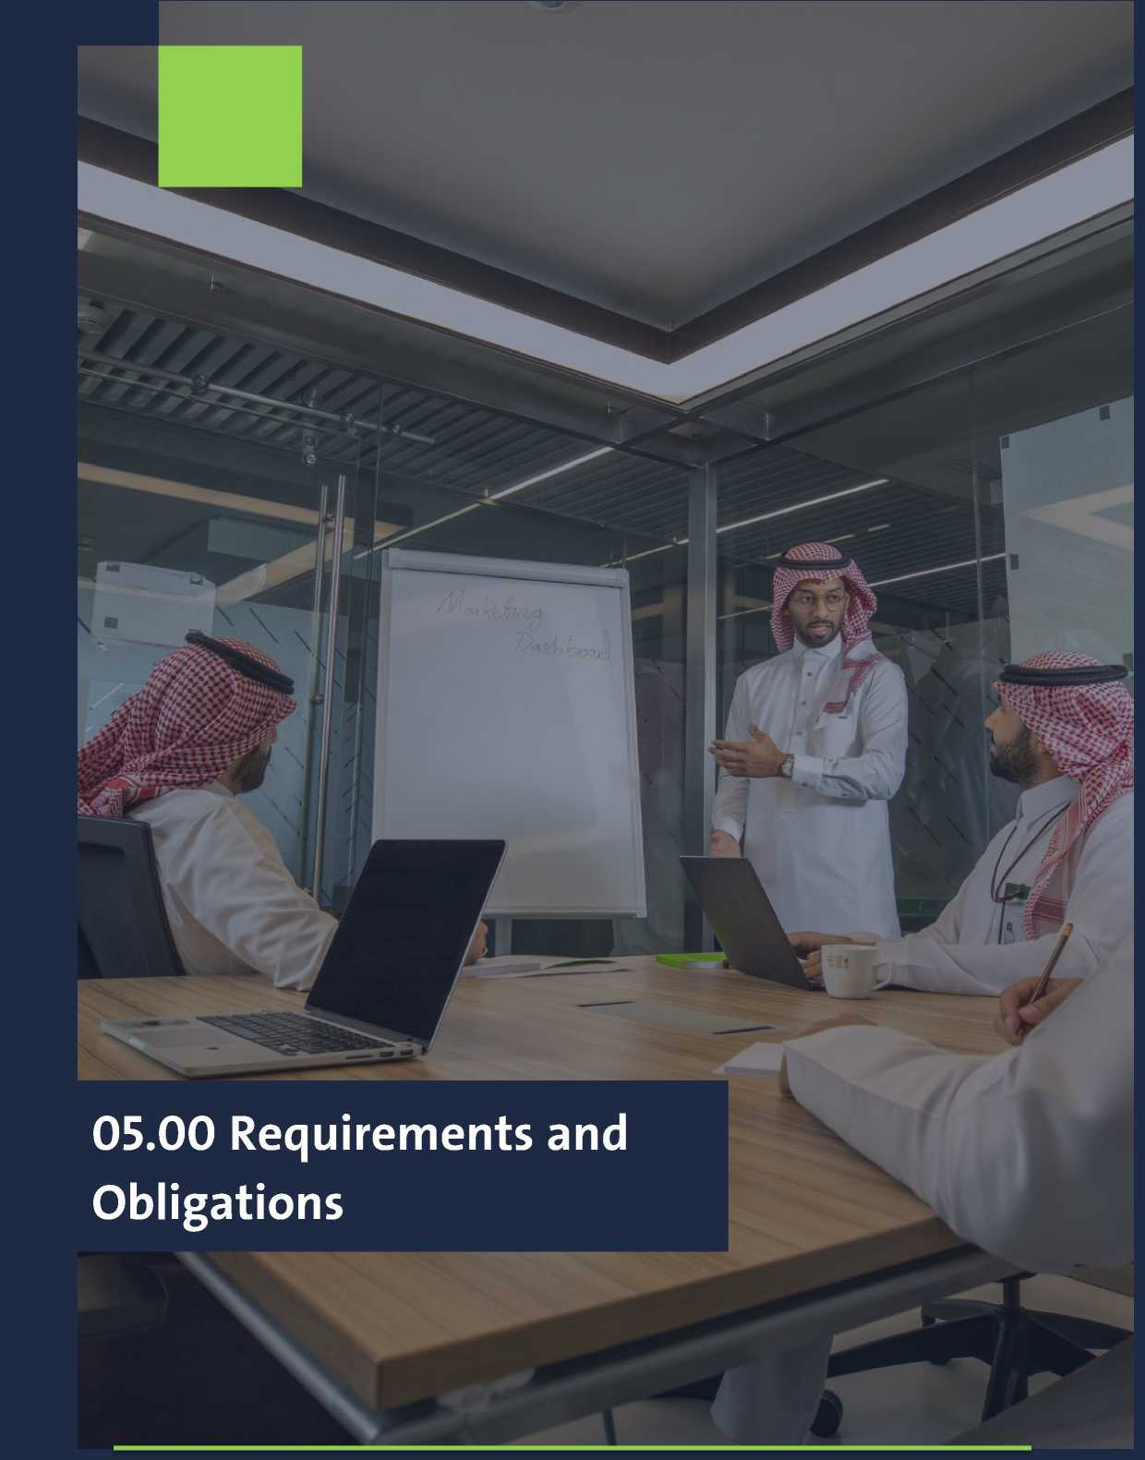

5.1 Requirements for registration of special
categories
45
5.1.1 Types of activities, their requirements, minimum capital
requirements, and national participation percentage
 | Type of Activity | Minimum Capital (SR) | Minimum Saudi  Participation (%) | Additional requirements
¹ | Commercial with Saudi partner | 26,666,667 | 25% | I
2 | 100% Foreign Commercia | 30,000,000 | - | ▪ Presence in at least (3) regional or global markets
3 | Communications Activities | - | 40% | -
4 | Supportive communications activities |  | 30%
5 | Professional Activities with  Saudi Partner | - | 25% | ▪ Both partners (local and foreign) must be licensed in the same field. If there is a nonprofessional partner, their share must not exceed 30%
6 | Engineering Consulting  Activities 100% Foreign | - | - | ▪ Presence in 4 countries  ▪ At least 10 years of experience
7 | 100% Foreign Legal Activity | - | - | Letter of approval from the Ministry of Justice
8 | Real Estate Development | *The value of each project shall not be less than 30,000,000 land and buildings outside the scope of Mecca and Medina | - | -

5.1 Requirements for registration of special
categories
46
5.1.1 Types of activities, their requirements, minimum capital
requirements, and national participation percentage
 | Type of Activity | Minimum Capital (SR) | Minimum Saudi  Participation (%) | Additional requirements
9 | Recruitment Agents and Domestic Worker Rental Activity | - | - | ▪ The commercial register of the establishment requesting registration for at least three years to practice the recruitment activity  ▪ Financial statements for the last 3 fiscal years of the foreign company applying for registration, certified by the Saudi Embassy  ▪ Submitting a performance evaluation certificate from the authority supervising the export activity in the sending country  ▪ The obligation to submit a certificate issued by the supervisory authority in the investor / investor country that no final judgment was issued against any of the natural partners for a crime involving dishonor or breach of trust, or any of the violations related to the provisions governing child protection or combating trafficking in persons, unless he is considered  ▪ Commitment to the undertaking that any of the partners has not previously obtained a license to export labor or was a partner in a company practicing this activity and its license has been revoked by a decision or a court ruling, unless at least five years have passed since that

5.1.2 Requirements for registering special
categories
47
 | Filing Categories | Definition | Requirements | Financial  Consideration | Filing Categories
¹ | Registration for Entrepreneurial Establishments | They are entrepreneurs and startups who wish to establish innovative, distinguished, or emerging technology companies that are capable of expansion and growth to provide a better and different product or service in the Saudi market and have support entities approved by the Ministry | ▪ If the applicant is a company, attach a decision from the company’s board of directors stating their desire to register in the Kingdom  ▪ Submit a letter of support or proof of project approval from the supervising authority (Saudi universities or accredited business incubators)  ▪ If the applicant is an individual residing in the Kingdom, a noobjection letter from the employer must be submitted | ▪ Registration  ▪ Annual Update | The establishment is obligated to pay the financial fee for the entire registration period, as determined by the Ministry when approving its registration, The establishment is obligated to pay within 30 days of notification of the due amount, If payment is not made within the specified period, the registration will be deemed void
2 | Temporary Registration for the implementation of a Government  Contracts | These are foreign companies that have obtained a government contract and apply for temporary investment registration to implementation the government/semi- government contract. This registration ends at the end of the contract | ▪ A copy of the letter from the government agency or the project implementation contract signed by the relevant authority, including the contract period | ▪ Registration  ▪ Annual Update | The establishment is obligated to pay the financial fee for the entire registration period, as determined by the Ministry when approving its registration, The establishment is obligated to pay within 30 days of notification of the due amount, If payment is not made within the specified period, the registration will be deemed void
3 | Registration for the  Scientific and  Technical Office | These are foreign companies that have a  Saudi agent or authorized distributor in the Kingdom and wish to open an office to provide scientific and technical services to agents, distributors, and consumers of the company's products | ▪ Certified copy of the Saudi agent or distributor | ▪ Registration  ▪ Annual Update | The establishment is obligated to pay the financial fee for the entire registration period, as determined by the Ministry when approving its registration, The establishment is obligated to pay within 30 days of notification of the due amount, If payment is not made within the specified period, the registration will be deemed void

5.1.2 Requirements for registering special
categories
48
 | Filing Categories | Definition | Requirements | Financial  Consideration | Filing Categories
4 | Registration for Economic and  Technical Liaison  Offices | These are the economic and technical offices of countries wishing to register in the Kingdom for the purpose of studying markets and preparing reports on this study for the relevant institutions in their country without executing any contracts or carrying out commercial or investment activity in the Kingdom, directly or indirectly. | ▪ A decision addressed to the Ministry of  Investment from the ministries, government institutions, or relevant institutions to open an economic and technical liaison office in the  Kingdom ▪ Submit a letter from the Ministry of Foreign Affairs addressed to the  Ministry of  Investment requesting registration for an Economic and Technical Liaison Office, including a detailed business plan for the activities and services required to be provided within the Kingdom | ▪ Registration  ▪ Annual Update | The establishment is obligated to pay the financial fee for the entire registration period, as determined by the Ministry when approving its registration, The establishment is obligated to pay within 30 days of notification of the due amount, If payment is not made within the specified period, the registration will be deemed void
5 | Regional Headquarters (RHQ)  License | It is a foreign multinational company that wishes to establish an entity in the Kingdom of Saudi Arabia as its regional headquarters, in accordance with the laws of the Kingdom of Saudi Arabia, for the purposes of supporting, managing, and strategically directing its branches and subsidiaries operating in the Middle East and North Africa region | A copy of two different commercial records of the establishment, certified by the Saudi embassy, except for the Kingdom of Saudi Arabia and the country in which the headquarters of the two heads of state are located | ▪ Registration  ▪ Annual Update | The establishment is obligated to pay the financial fee for the entire registration period, as determined by the Ministry when approving its registration, The establishment is obligated to pay within 30 days of notification of the due amount, If payment is not made within the specified period, the registration will be deemed void

49
    - Additional obligations based on the
category and type of registered activity
Additional obligations that applicants for registration must
adhere to depending on the type of investment registration upon
issuance:
 |  | Categories/Activity | Obligations
1 | Commercial activity (100% foreign Ownership) |  | - Training 30% of Saudis.  - The company shall comply to achieve following standards during the first five years:  - The company shall comply to achieve the localization rates as determined by the Ministry of Human Resource and Social Development. The company shall develop and implement a plan to locate them in senior management posts in the first five years and to ensure their continuation.  - The company is complying with train (30%) of Saudi employees annually.  - The company shall comply to achieve one of the following options:  - Option 1: the company shall comply with investing an amount of no less than (300) million Saudi Riyals (including 30 million Saudi Riyals as the cash capital of the company) over five years starting from the date of obtaining the investment license.  - Option 2: the company shall comply with investing an amount of no less than (200) million Saudi Riyals (including 30 million Saudi Riyals as the cash capital of the company) over five years starting from the date of obtaining the investment license, in addition to achieving one or more of the following requirements during the first five years:
 |  |  | The standard | The minimum requirement
 |  |  | Manufacturing | 30% or more of the company's products distributed locally shall be manufactured in the Kingdom of Saudi Arabia
 |  |  | Research and development programs | 5% or more of total sales shall be allocated to the establishment of a research  and development programs in the Kingdom
 |  |  | Logistics and distribution | The establishment of a unified center to provide those services, and provide after-sales services
2 | Scientific and Technical Office |  | - The office shall perform market feasibility studies on the type of the company’s activity, and prepare reports of this study for the main center. The office shall submit an annual summary of its activities to Ministry of Investment.  - The office is prohibited from performing any contracts or commercial activities or investments in the Kingdom, directly or indirectly, while it is also prohibited from earning any fees for training Saudi technicians.  - Ministry of Investment has the right to revoke the license or not to renew it whenever it deems that the office's role is beyond the authorized purpose.

50
    - Additional obligations based on the
category and type of registered activity
Additional obligations that applicants for registration must
adhere to depending on the type of investment registration upon
issuance:
 | Categories/Activity | Obligations
3 | Registration for Economic and Technical Liaison Offices | - The office may study the markets and prepare reports on this study for the relevant institutions in the country wishing to obtain registration, The office must submit an annual summary of its activities to the Ministry of Investment.  - The office is prohibited from performing any contracts or commercial activities or investments in the Kingdom, directly or indirectly.  - Ministry of Investment has the right to revoke the license or not to renew it whenever it deems that the office's role is beyond the authorized purpose.
4 | Regional Headquarters (RHQ) License | - The RHQ is established as a separate legal personality in the Kingdom of Saudi Arabia either as a company or as a registered branch of a foreign company.  - The RHQ shall not directly conduct commercial operations that generate revenue other than RHQ License activities.  - The RHQ must commence the mandatory RHQ activities* within six months of issuing the License.  - The RHQ must commence at least three optional RHQ activities** within one year of issuing the RHQ License(The applicant selects the optional activities when applying for registration).  - RHQ employees carrying on mandatory RHQ activities must have the relevant skills and knowledge developed at the headquarters or another regional headquarters of the Multinational Group, at least 3 employees of which must be of Executive Director level and Vice-President level.  - The RHQ must employ at least 15 full time employees deployed in the conduct of RHQ activities within one year of issuing the RHQ Register (including the senior level executives mentioned in point above).
5 | All registered categories/All Economic activities | • Establishments are committed to filling out the questionnaire shared with them by the Ministry, within a period not exceeding (14) working days from the date of notification, in order to avoid the investment establishment being subject to any effects that may result from the delay in providing the required data.

51



06.00: Communication with the
Ministry of Investment

52
06.01 Communication Mechanism with the Ministry of Investment
- Contacting the Ministry of Investment
The Ministry of Investment offers multiple ways to get in touch with its Investor Care Team:
- Toll-Free Numbers:
o Inside Saudi Arabia: 8002449990
o Outside Saudi Arabia: +966112035777
- Live Chat:
o Visit the Ministry's website www.misa.gov.sa, log in to your company account, and click on the help icon for instant messaging.
- Callback Requests:
o Visit www.misa.gov.sa and request a callback via your company's account.
- Social Media:
o Twitter: @MISACare
- Email:
o Email: InvestorCare@misa.gov.sa


فكككككم
24.737844- 46-637261
Google Map
21.633861, 39.133348
8002449990
Google Map
26.348312 ,50.196423
24.482325207094007
39.57270753320472
Prince Sultan Street, after the intersection
with Hope Street, heading north
Building Number: 7241
Additional Number: 2810
Postal Code: 23621
Prince Sultan Street, after the intersection
with Hope Street, heading north
Building Number: 7241
Additional Number: 2810
Postal Code: 23621
Tariq bin Ziad Street (intersection with
Granada Street)
Al-Rakah Al-Janubiyah District
Building Number: 7296
Additional Number: 2231
Postal Code: 34227
Imam Saud Bin Abdulaziz Bin Mohammad
Road, after the intersection with Takhassusi
Street heading west
National Address:
Building Number: 3912
Additional Number: 6229
Postal Code: 12382
Detailed Address
Coordinates
Free number

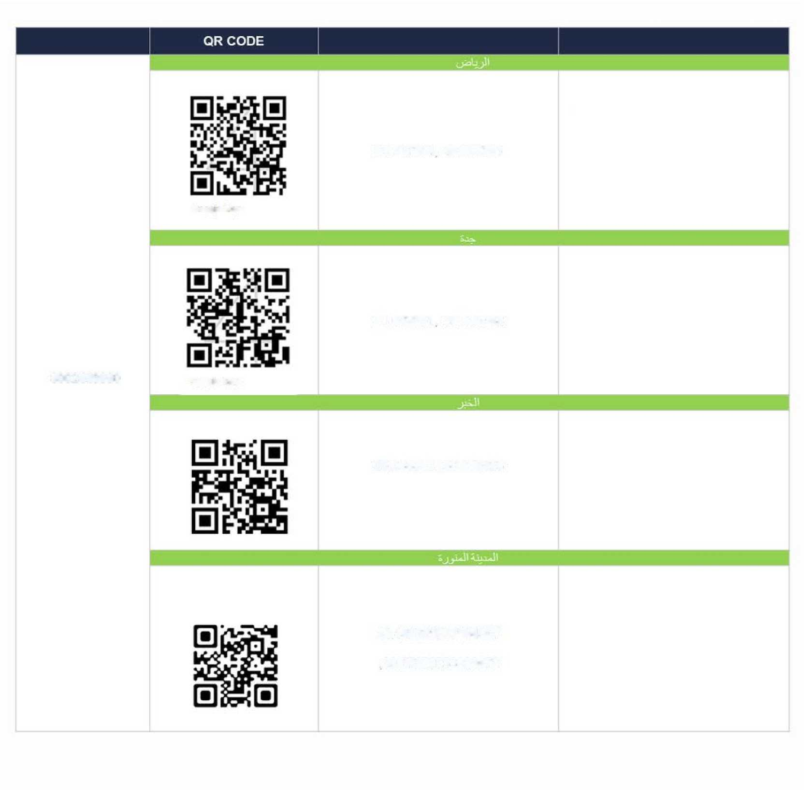

٦
ارخ

f
07.00: Attachments



55

07.01 List of violations
The Ministry is responsible for monitoring gross and non-corporeal violations against the registered establishment in accordance with what is stipulated in the executive regulations of the investment system.
07.01.01 List of serious violations:
- Engaging in an investment activity without the registration.
- Practicing investment in exempt activities without obtaining approval, or after its expiration or cancellation, or in violation of the conditions related to its practice.
- Change of ownership of restricted activities without prior approval.
- The investor provides misleading or incorrect information to the ministry or competent authority.
- The investor prevents or obstructs the regulatory official from carrying out his duties under the regulations.

56

07.01 List of violations
The Ministry is responsible for monitoring gross and non-corporeal violations against the registered establishment in accordance with what is stipulated in the executive regulations of the investment system.
07.01.01 List of serious violations:
- Engaging in an investment activity without reactivating the registration.
- Failure to provide the Ministry with the requested documents, information, or data for the purpose of assessing compliance with the required conditions for conducting activities.
- Relocating or changing the establishment’s site without notifying the Ministry within ten (10) working days of the change.
- Changing or modifying the establishment’s account manager details without notifying the Ministry within ten (10) working days of the change.
- Non-compliance with the mandatory conditions for conducting permitted activities.

